# **DIABETIC MELLITUS PREDICTION USING IBM AUTOAI**

# **1.INTRODUCTION**

Diabetes is a common chronic disease and poses a great threat to human health. The characteristic of diabetes is that the blood glucose is higher than the normal level, which is caused by defective insulin secretion or its impaired biological effects, or both. Diabetes can lead to chronic damage and dysfunction of various tissues, especially eyes, kidneys, heart, blood vessels and nerves. Diabetes can be divided into two categories, type 1 diabetes (T1D) and type 2 diabetes (T2D). Patients with type 1 diabetes are normally younger, mostly less than 30 years old. The typical clinical symptoms are increased thirst and frequent urination, high blood glucose levels. This type of diabetes cannot be cured effectively with oral medications alone and the patients are required insulin therapy. Type 2 diabetes occurs more commonly in middle-aged and elderly people, which is often associated with the occurrence of obesity, hypertension, dyslipidemia, arteriosclerosis, and other diseases.

**1.1 OVERVIEW**

Diabetes mellitus is a chronic disease characterized by hyperglycemia. It may cause many complications. According to the growing morbidity in recent years, in 2040, the world’s diabetic patients will reach 642 million, which means that one of the ten adults in the future is suffering from diabetes. There is no doubt that this alarming figure needs great attention. With the rapid development of machine learning, machine learning has been applied to many aspects of medical health for accurate predictions.

**1.2 PURPOSE**

This project prevents the people from the avalanche by priory informing them there is a chance to the occurrence of avalanche or not.In medicine, the diagnosis of diabetes is according to fasting blood glucose, glucose tolerance, and random blood glucose levels. The earlier diagnosis is obtained, the much easier we can control it. Machine learning can help people make a preliminary judgment about diabetes mellitus according to their daily physical examination data, and it can serve as a reference for doctors.

**2.LITERATURE SURVEY**

**2.1 EXISTING PROBLEM**

Diabetes mellitus or simply diabetes is a disease caused due to the increase level of blood glucose. Various traditional methods, based on physical and chemical tests, are available for diagnosing diabetes. Early prediction of diabetes is quite challenging task for medical practitioners due to complex interdependence on various factors as diabetes affects human organs such as kidney, eye, heart, nerves, foot etc

**2.2 PROPOSED SOLUTION**

This project prevents the people from the avalanche by priory informing them there is a chance to the occurrence of avalanche or not.The aim of this project is to develop a system which can perform early prediction of diabetes for a patient with a higher accuracy by combining the results of different machine learning techniques and the model is been built in Auto AI.

**3.THEORITICAL ANALYSIS**

**3.1 BLOCK DIAGRAM**

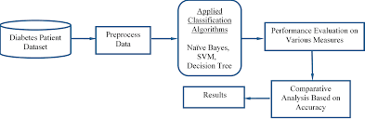

**3.2 HARDWARE/SOFTWARE SOLUTION**

**PROJECT REQUIREMENTS**

1. A Classification algorithm with maximum accuracy to be trained and tested on the dataset.
2. The Dataset consists of 8 columns excluding the predicting column i.e. Class

**SOFTWARE REQUIREMENTS**

1. IBM Cloud
2. IBM Watson Studio
3. Node-red App

**4.EXPERIMENTAL INVESTIGATION**

1. **Choose a Project Idea:**

Predicting Diabetic Mellitus of a person using AutoAI.

1. **Conduct Background Research:**

<https://www.kaggle.com/akhilalexander/diabeticprediction>

1. **Compose a Hypothesis:**

Based on our study and information gathered we can predict whether a person has diabetes or not.

1. **Design your Experiment:**

First we need to collect the suitable dataset for our problem statement. Next we need to run the AutoAI experiment for this problem and use the algorithm which has the highest accuracy.

1. **Draw Conclusions:**

After building our model, we can predict the class of a person(i.e.0 or 1).

**5.FLOWCHART**

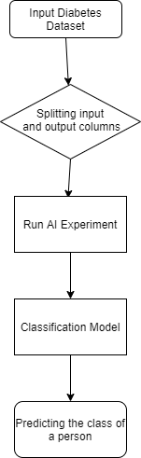

**6.RESULT**

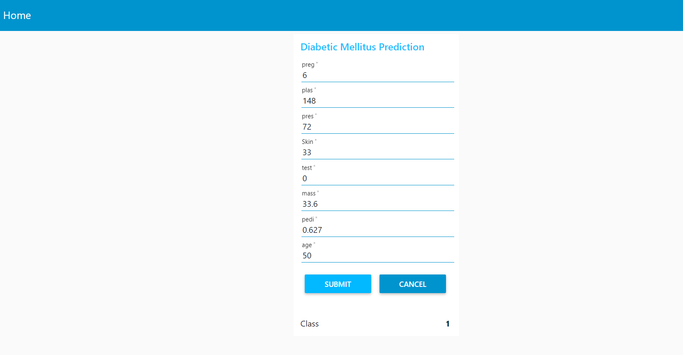

**7.ADVANTAGES AND DISADVANTAGES**

**ADVANTAGES**

* This project prevents the people from the avalanche by priory informing them there is a chance to the occurrence of avalanche or not.
* The earlier diagnosis is obtained, the much easier we can control it
* Machine learning can help people make a preliminary judgment about diabetes mellitus according to their daily physical examination data, and it can serve as a reference for doctors.
* The advantage of using AutoAI is we dont need to write the code we just have to give dataset as input,it automatically builds the model using AutoAI pipeline and gives the model with highest accuracy.

**DISADVANTAGES**

**Deterministic problems:**This method is not very efficient for deterministic problems.

**Lack of good data**:it may leads to problems.

Interpretability

**8.APPLICATIONS**

* The application is used to predict diabetes for users.
* This system can serve as a reference for doctors.

**9.CONCLUSION**

Diabetes mellitus is a disease, which can cause many complications. How to exactly predict and diagnose this disease by using machine learning is worthy studying.The end product is an webpage created and deployed on node-red app of IBM cloud. The backend of webpage is XGBoost Classifier built in AutoAI with 0.770 accuracy and deployed on watson studio using machine learning service.

The web page has input fields such as Preg,Plas,Pres,Skin,Test Mass,Pedi,Age and an output field named as Class which gives 0 or 1 based on the inputted values.

**10.FUTURE SCOPE**

Living with diabetes is challenging and distressful. Diabetic patient’s condition cannot be understood only from his with medical charts. There is a need to collect and analyze both subjective and objective patient information in order to fully understand the occurrence of readmission of patients with diabetes.This predicting information might improve the intelligent models to identify patients at high risk of readmission.

**11.BIBILOGRAPHY**

<https://www.researchgate.net/publication/328766758_Predicting_Diabetes_Mellitus_With_Machine_Learning_Techniques>

**12.APPENDIX**

Node-RED Flow Output

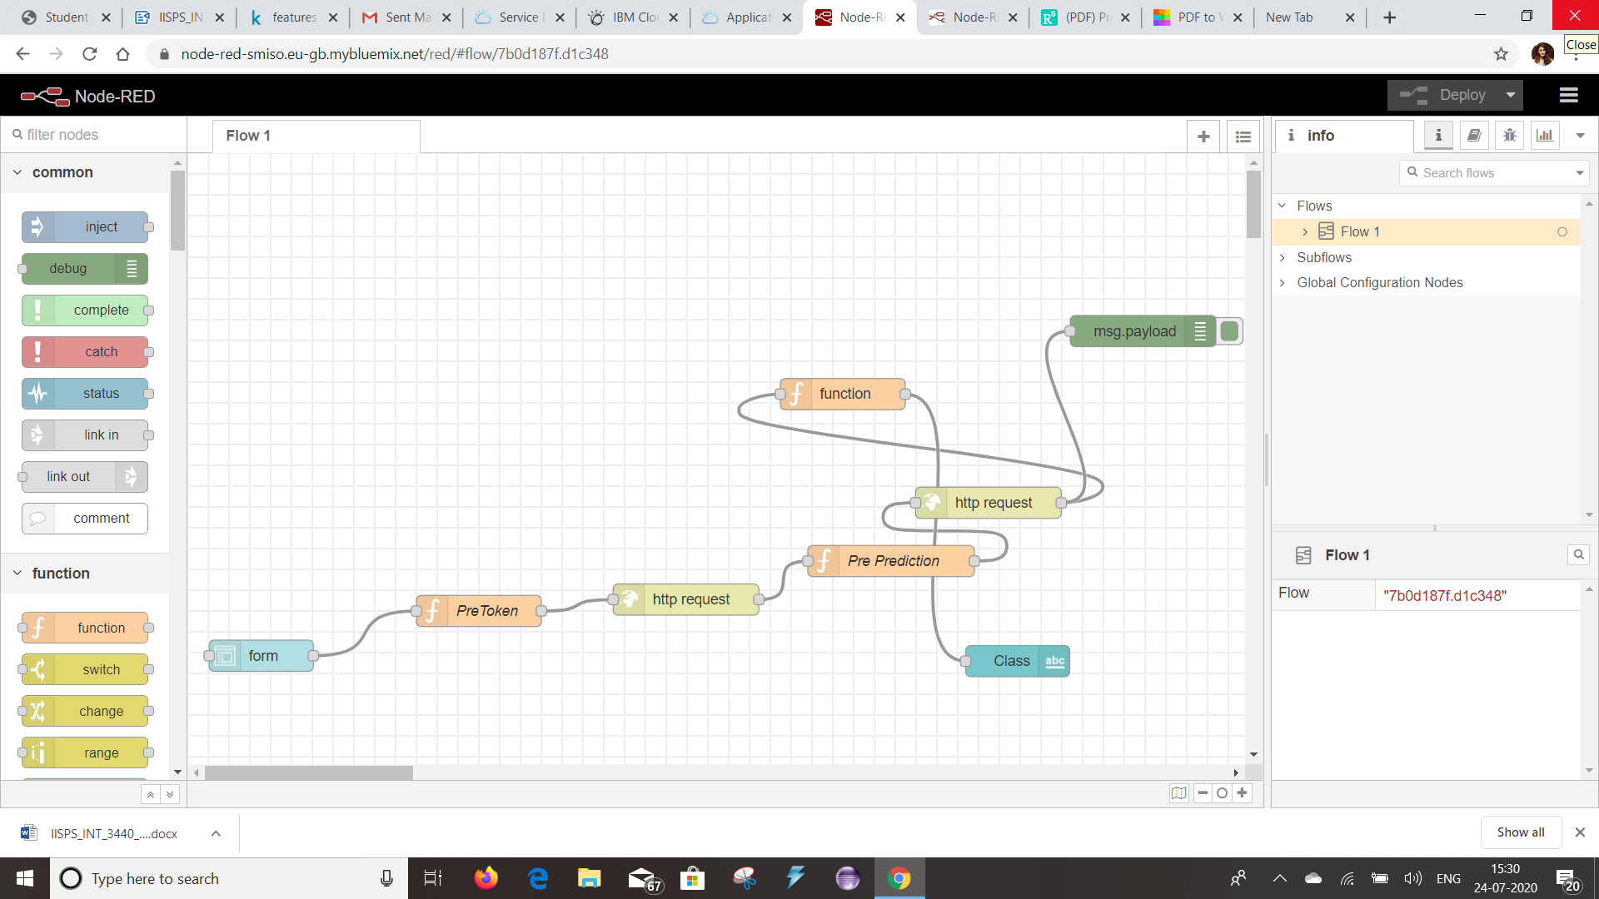

**UI OUTPUT SCREENSHOT**

